1.Create Database

1.Sql_invoicing

2.sql_store

3.Sql_hr

4. sql_inventory

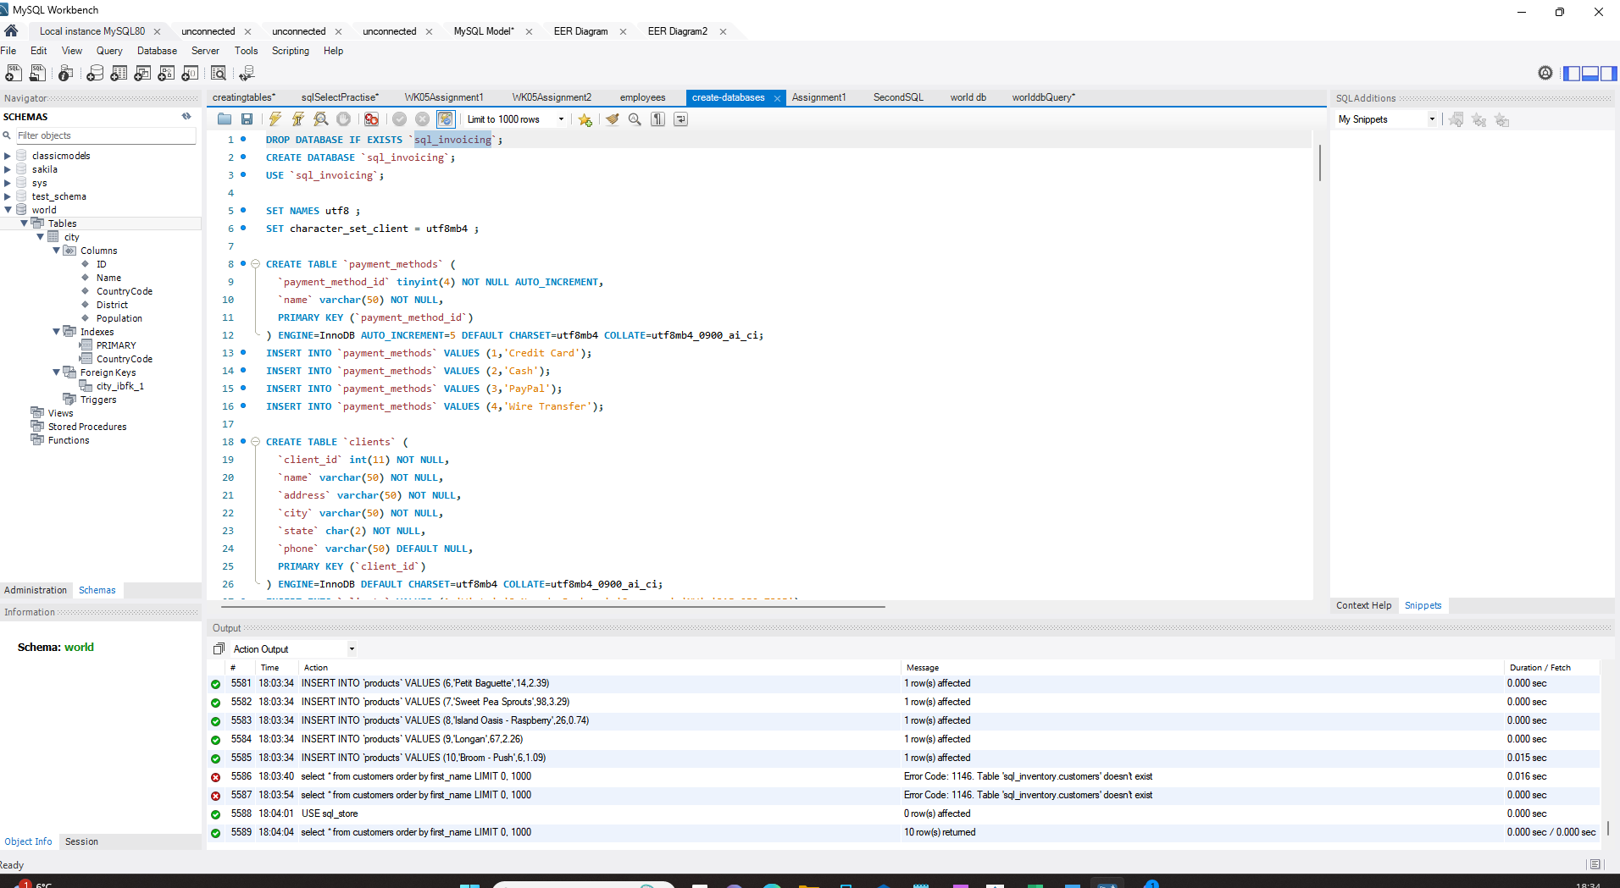

**Query 1:**

USE sql_store;

SELECT * FROM customers

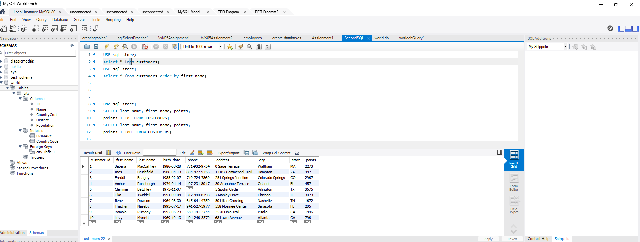

**Query2**

Add the following into the file Query 1 -- WHERE CUSTOMER_ID=1 order by first_name;

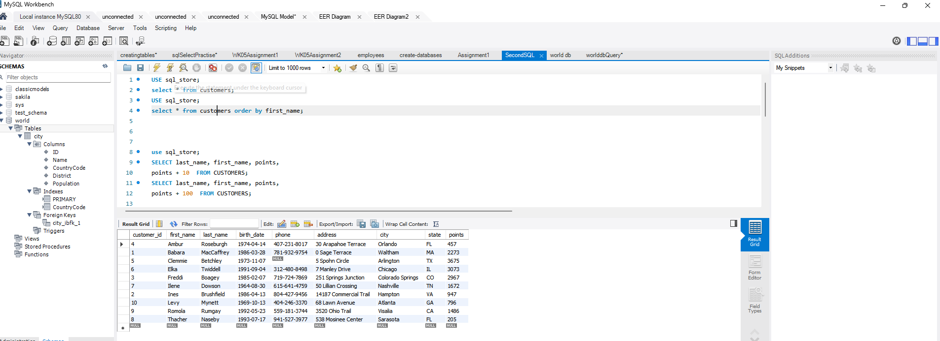

**Query3:**

• SELECT last_name, first_name, points, points + 10 • FROM CUSTOMERS

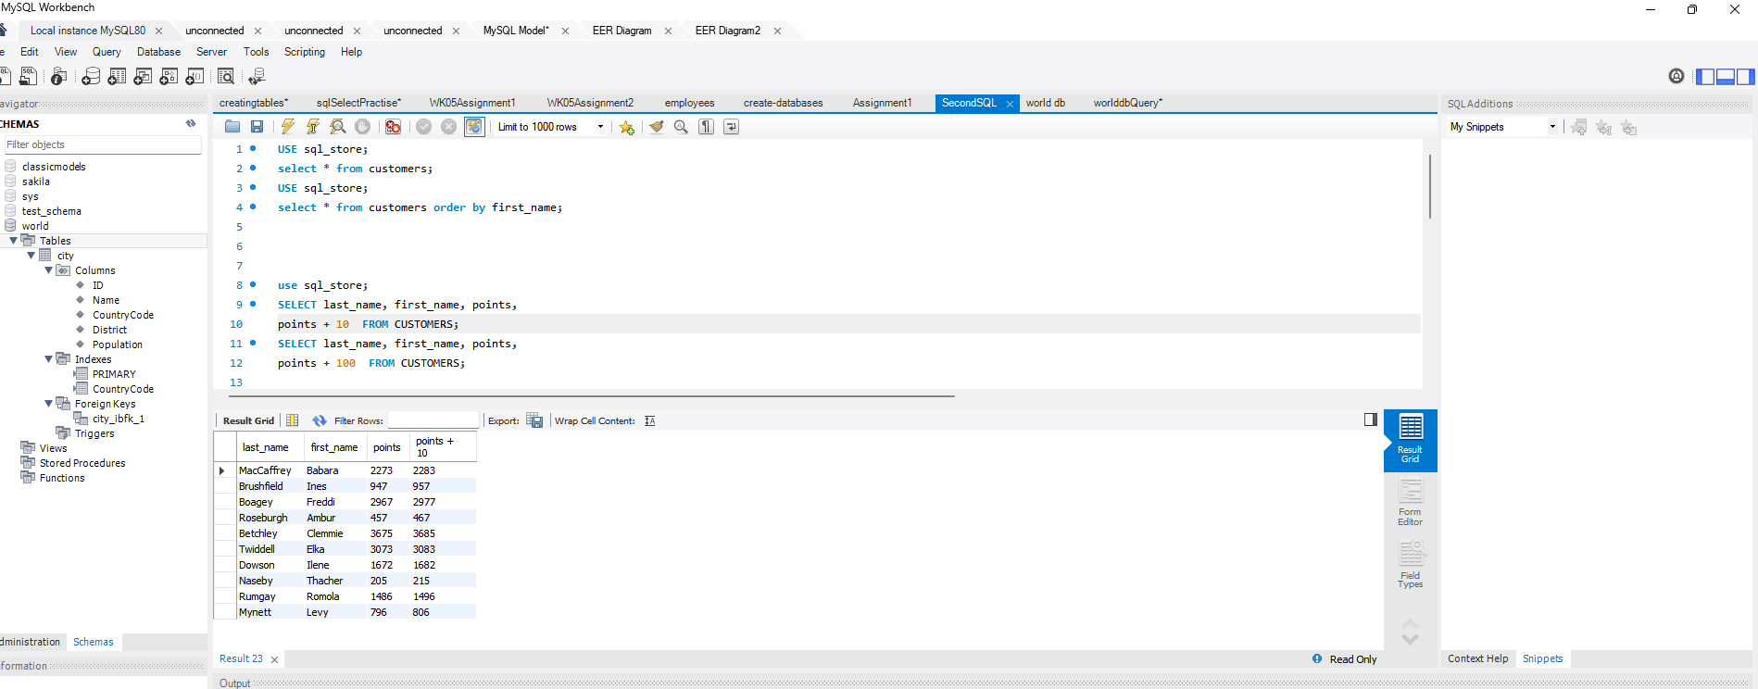

**Query 4:**

Using the Query 2 you created change the points to reads times by 10 and plus 100. Record your results in your word document

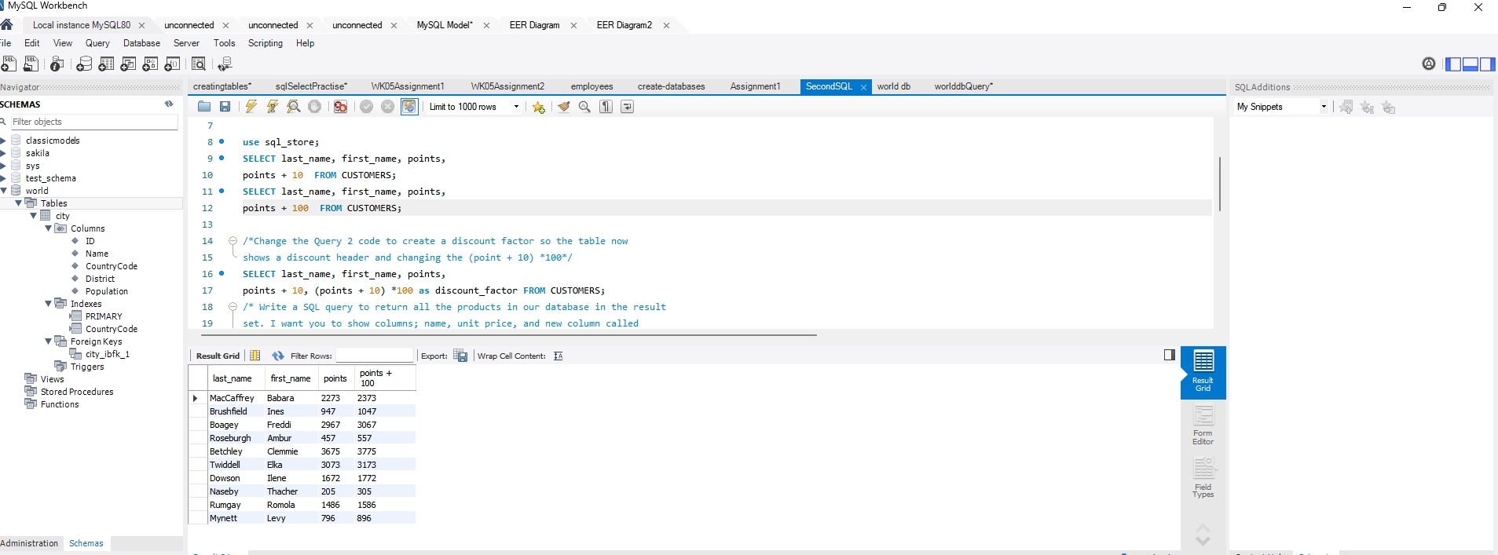

**Query5:**

Change the Query 2 code to create a discount factor so the table now shows a discount header and changing the (point + 10) *100

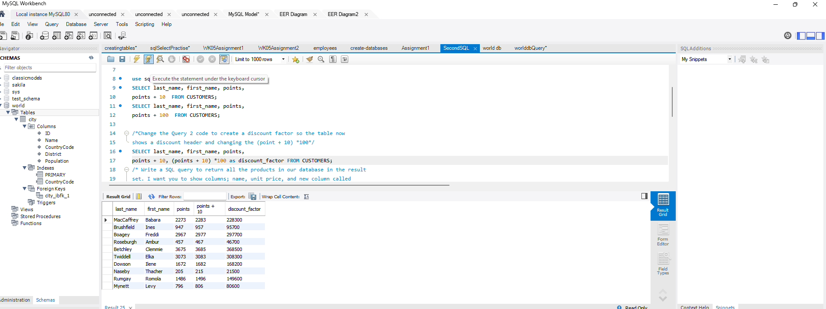

**Query6:**

Write a SQL query to return all the products in our database in the result set. I want you to show columns; name, unit price, and new column called new price which is based on this expression, (unit price * 1.1 ). So what you are doing is increasing the product price of each by 100;

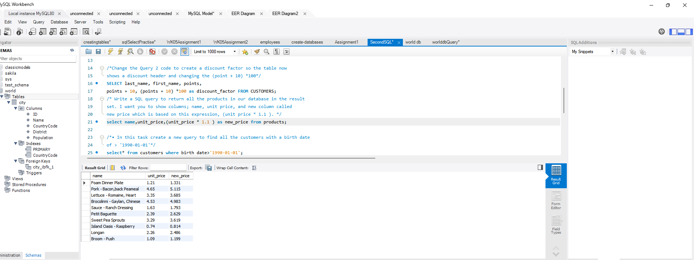

**Query 7:**

In this task create a new query to find all the customers with a birth date of > '1990-01-01'

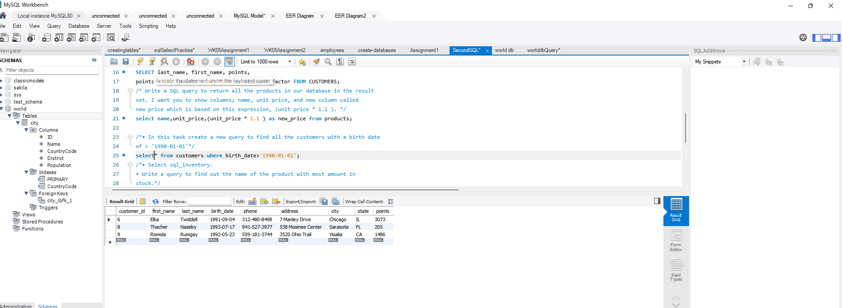

**Query 8:**

Select sql_inventory.

• Write a query to find out the name of the product with most amount in stock.

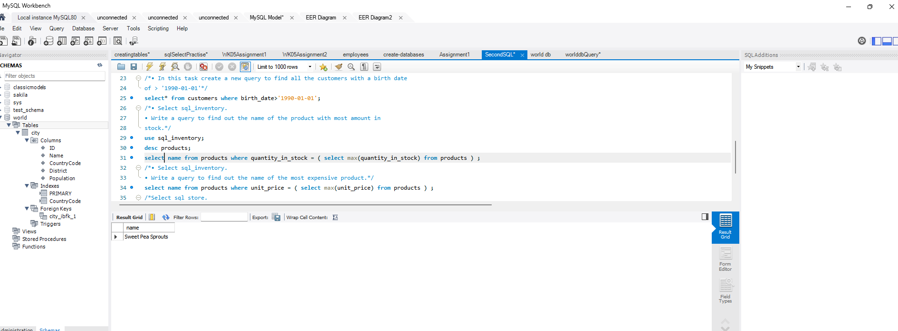

**Query 9:**

Select sql_inventory.

• Write a query to find out the name of the most expensive product.

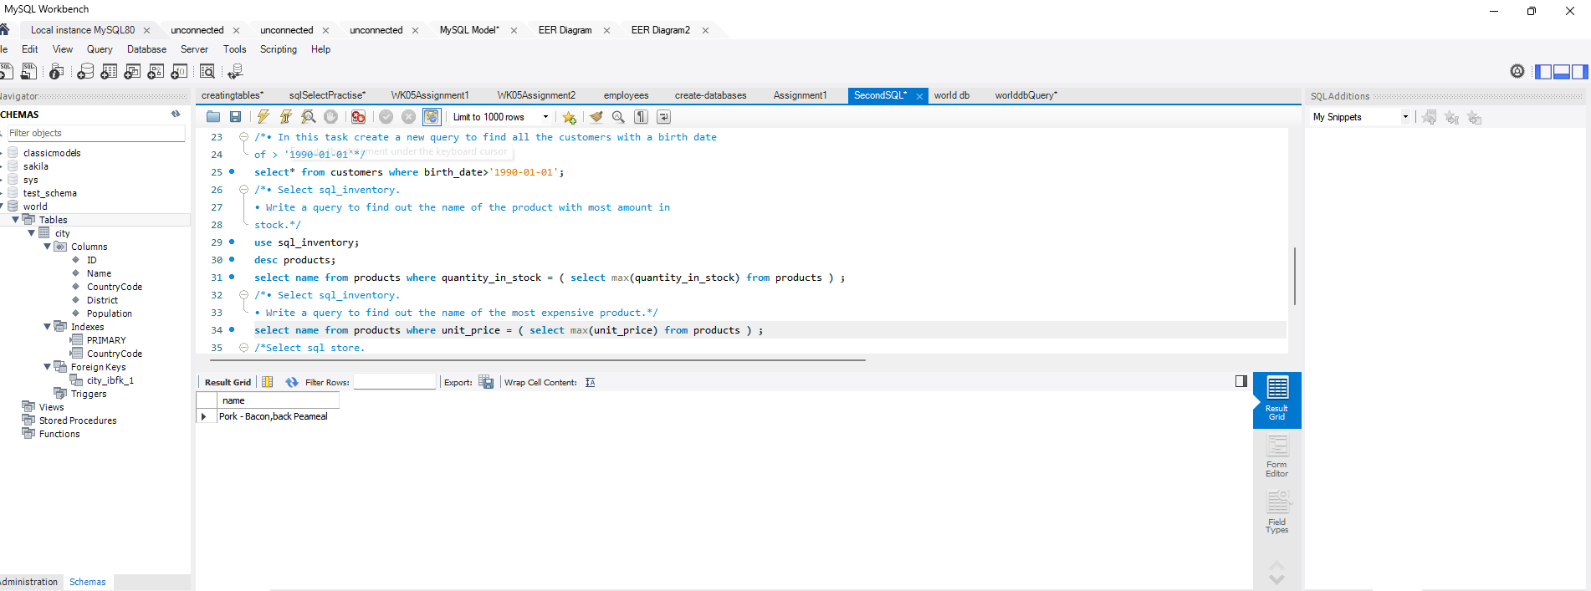

**Query 10:**

• Select sql_store.

• Write a query to find out the first name, last name, address and the birthdate of the oldest customer.

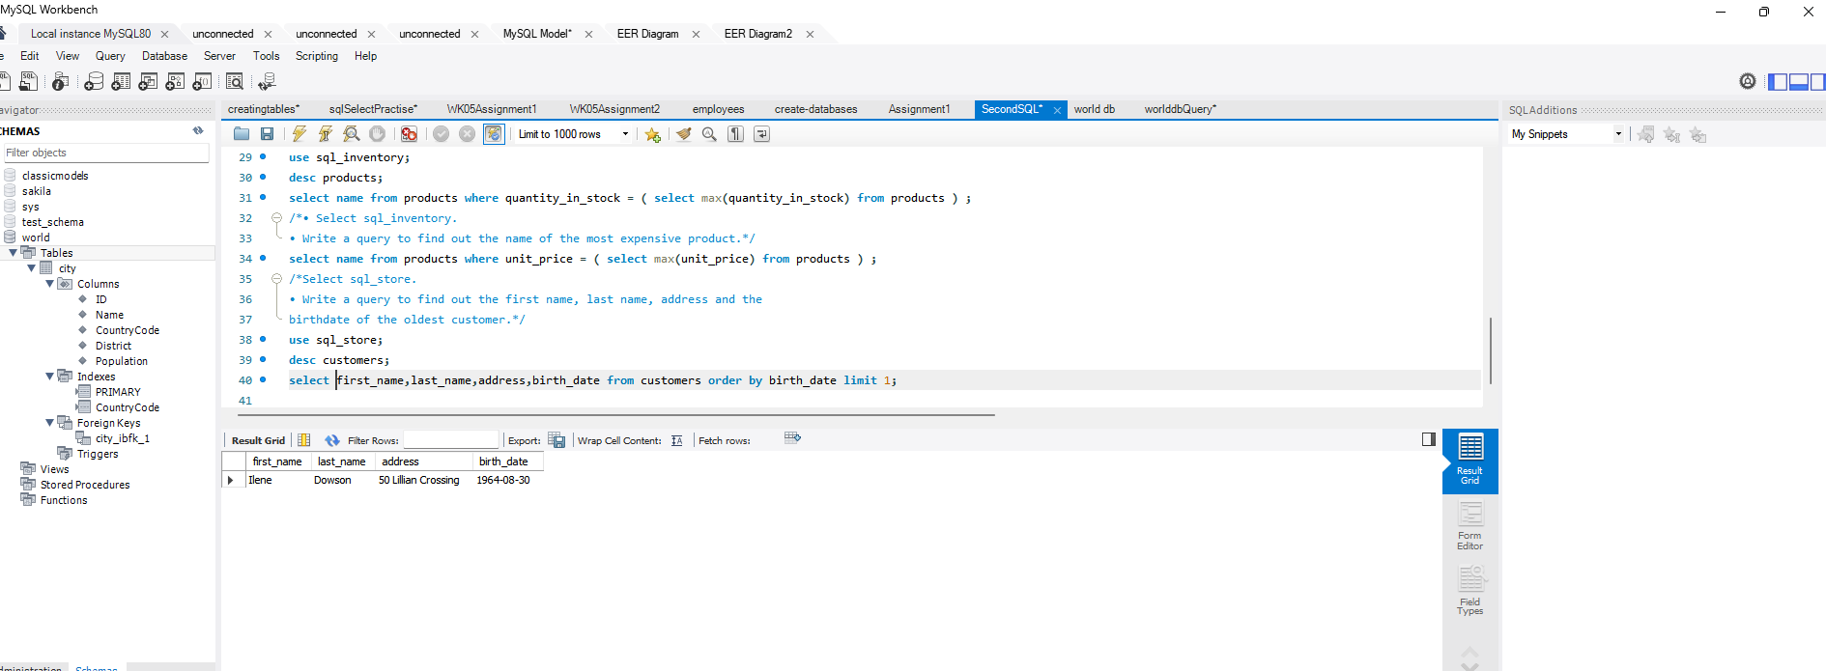

**ERDiagram for Database:**

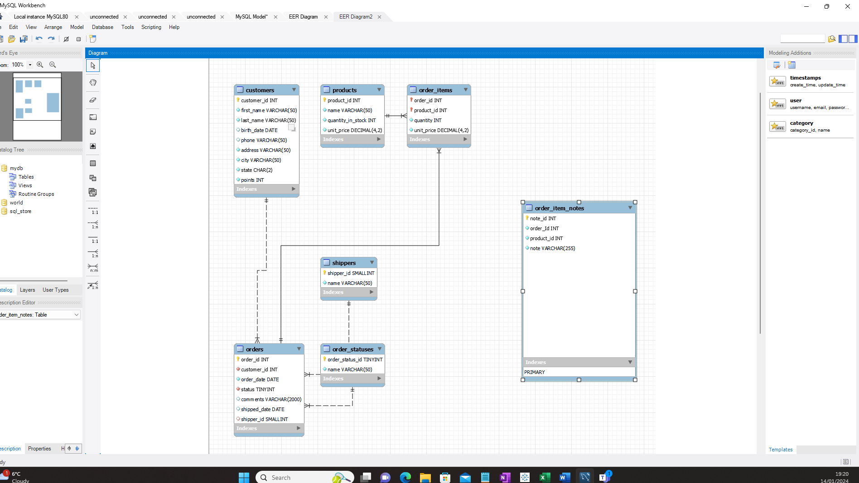

•Identify the primary key in Customers. - customer_id

•Identify the primary key in orders table. - order_id

•Identify the primary key in products table. - product_id

•Identify the primary key in order_items table. - order_id+Product_id

* Identity the foreign key in orders table-customer_id is the foreign key for customer_id in the customers table

•Identify the primary key in shippers table -shippers_id

* There are one-many relationship existing between customers and Orders table.
* There are one-many relationship existing between orders and Order_items table.
* There are one-many relationship existing between products and Order_items table.
* There are one-many relationship existing between orders and Order_statuses table.